Software Requirements Specification

for

Extracurricular Management System

**Version 1.0**

**Prepared by**

**Group Name: fiesta**

|  |  |  |
| --- | --- | --- |
| **<name>** | **<student #>** | **<e-mail>** |
| **<name>** | **<student #>** | **<e-mail>** |
| **<name>** | **<student #>** | **<e-mail>** |
| **<name>** | **<student #>** | **<e-mail>** |
| **<name>** | **<student #>** | **<e-mail>** |

|  |  |
| --- | --- |
| **Instructor:** | **Dr. N. Harini** |
| **Course:** | **Netcentric Programming** |
| **Lab Section:** | ***<place your lab section here>*** |
| **Teaching Assistant:** | ***<place your TA’s name here>*** |
| **Date:** | **24-09-2020** |

**Contents**

**CONTENTS II**

**REVISIONS II**

**1** **INTRODUCTION 1**

1.1 Document Purpose 1

1.2 Product Scope 1

1.3 Intended Audience and Document Overview 1

1.4 Definitions, Acronyms and Abbreviations 1

1.5 Document Conventions 1

1.6 References and Acknowledgments 2

**2** **OVERALL DESCRIPTION 2**

2.1 Product Overview 2

2.2 Product Functionality 3

2.3 Design and Implementation Constraints 3

2.4 Assumptions and Dependencies 3

**3** **SPECIFIC REQUIREMENTS 4**

3.1 External Interface Requirements 4

3.2 Functional Requirements 4

3.3 Use Case Model 5

**4** **OTHER NON-FUNCTIONAL REQUIREMENTS 6**

4.1 Performance Requirements 6

4.2 Safety and Security Requirements 6

4.3 Software Quality Attributes 6

**5** **OTHER REQUIREMENTS 7**

**APPENDIX A – DATA DICTIONARY 8**

**APPENDIX B - GROUP LOG 9**

**Revisions**

|  |  |  |  |
| --- | --- | --- | --- |
| **Version** | **Primary Author(s)** | **Description of Version** | **Date Completed** |
| Draft Type and Number | Full Name | Information about the revision. This table does not need to be filled in whenever a document is touched, only when the version is being upgraded. | 00/00/00 |

# Introduction

*<TO DO: Please provide a brief introduction to your project and a brief overview of what the reader will find in this section.>*

## Document Purpose

Extracurricular activities are a vital part of the student experience, fostering lifelong skills and providing added value beyond the curriculum. While there is a widely accepted necessity for a Learning Management System (LMS) to assist with the delivery of the curriculum, a large number of schools don’t utilize an [Extracurricular Management System (EMS)](https://en.wikipedia.org/wiki/Extracurricular_activity#Extracurricular_Management_Systems) to operate their extracurricular programs. Instead, Colleges, schools often use a combination of paper, spreadsheets, online forms, SIS modules and other disparate systems. This creates a lack of visibility and often leads to data security risks, as well as inaccurate information.

## Product Scope

The purpose of this document is to present a detailed description of the Extracurricular Management System. An EMS is a purpose-built platform designed to help schools manage the administration of their extracurricular activities. It is a one-stop-shop for extracurricular data and processes, allowing schools to access reporting and analytic’s that they would otherwise be unable to utilize. This document is intended for both the user and developer of the software.

## Intended Audience and Document Overview

* Typical Users, such as students, who want to use Extracurricular Management System (EMS) for checking latest details and managing their data and also by modifying their details for displaying what they want to.
* Advanced/Professional Users, such as project managers, who want to use our EMS for organizing new events, or even modifying any details.
* Marketing staff, who want to use our EMS for show-casing, displaying and rating the upcoming events.
* Programmers who are interested in working on the project by further developing it or fix existing bugs.
* Professors for checking whether it intends to do the right work.

The best suggested flow for the readers is to follow the standard first to last order for more clarity and understanding of our standing and the taken steps for designing the Extracurricular Management System.

The rest of the document discusses about the overall product description such as what our product is intended in doing, and also describing whether our product is a replacement for certain existing systems, or a new, self-contained product. The document also describes the product functionality it’s design and implementation constraints, also the assumptions we took into our considerations by collecting the required dependencies. By also describing the specific requirements of our product whether these requirements are functional or not, and finally we have an appendix.

## Definitions, Acronyms and Abbreviations

* EMS - Extracurricular Management System
* LMS - Learning Management System
* HTML - The standard markup language for documents designed to be displayed in a web browser.
* CSS - describes how HTML elements are to be displayed on screen
* My SQL - The database that will be used for this project

## Document Conventions

This Document was created based on the IEEE template for System Requirement Specification Documents.

## References and Acknowledgments

1) [https://github.com/aehlke/tag-it](https://meet.google.com/linkredirect?authuser=0&dest=https%3A%2F%2Fgithub.com%2Faehlke%2Ftag-it)

2) [bulma.io](https://www.bulma.io)

# Overall Description

## Product Overview

*<Describe the context and origin of the product being specified in this SRS. For example, state whether this product is a follow-on member of a product family, a replacement for certain existing systems, or a new, self-contained product. If the SRS defines a component of a larger system, relate the requirements of the larger system to the functionality of this software and identify interfaces between the two. In this part, make sure to include a simple diagram that shows the major components of the overall system, subsystem interconnections, and external interface. In this section it is crucial that you will be creative and provide as much information as possible.*

*TO DO: Provide at least one paragraph describing product perspective. Provide a general diagram that will illustrate how your product interacts with the environment and in what context it is being used. This is not a formal diagram, but rather something that is used to illustrate the product at a high level.>*

## Product Functionality

*<Summarize the major functions the product must perform or must let the user perform. Details will be provided in Section 3, so only a high level summary is needed here. These can be at the level given in the project description.>*

*TO DO:*

*1. Provide a bulleted list of all the major functions of the system*

## Design and Implementation Constraints

*<Describe any items or issues that will limit the options available to the developers. These might include: hardware limitations (timing requirements, memory requirements); interfaces to other applications; specific technologies, tools, and databases to be used; parallel operations; language requirements; communications protocols; security considerations; design conventions or programming standards (for example, if the customer’s organization will be responsible for maintaining the delivered software). You can be creative here to some degree. At a minimum, you need to identify that you must use the COMET method for software design and the UML modeling language. Make sure you provide references for both. >*

## Assumptions and Dependencies

*<List any assumed factors (as opposed to known facts) that could affect the requirements stated in the SRS. These could include third-party or commercial components that you plan to use, issues around the development or operating environment, or constraints. The project could be affected if these assumptions are incorrect, are not shared, or change. Also identify any dependencies the project has on external factors, such as software components that you intend to reuse from another project.*

*TO DO: Provide a short list of some major assumptions that might significantly affect your design.>*

# Specific Requirements

## External Interface Requirements

### User Interfaces

The web app will interface with most browsers, especially Internet Explorer, Firefox and Safari. As long as the user has knowledge to operate a web browser, they will be able to operate our website efficiently.

1. Landing page - 1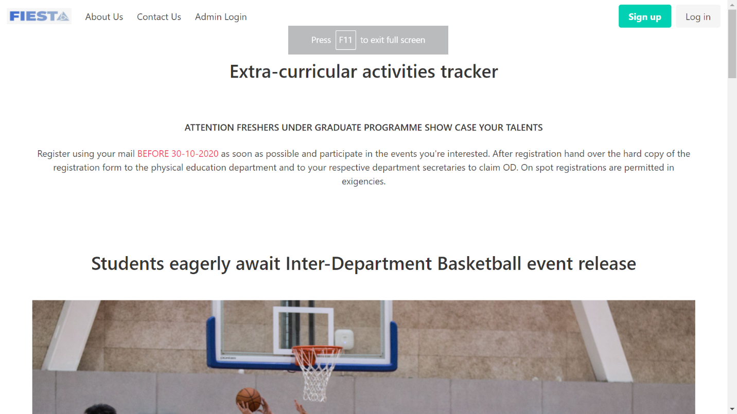
2. Landing page -2 with small descriptions and images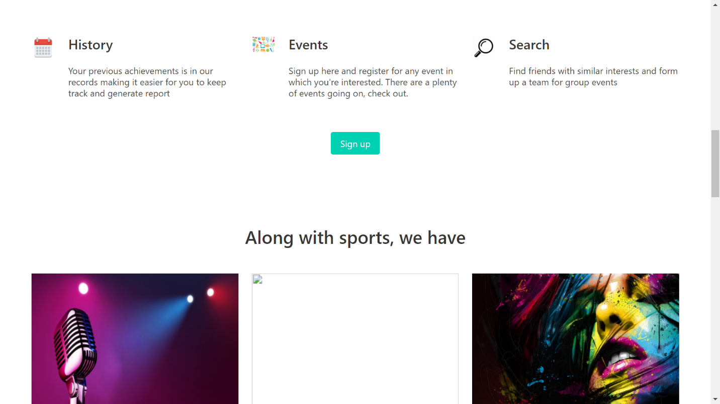
3. Contact Us page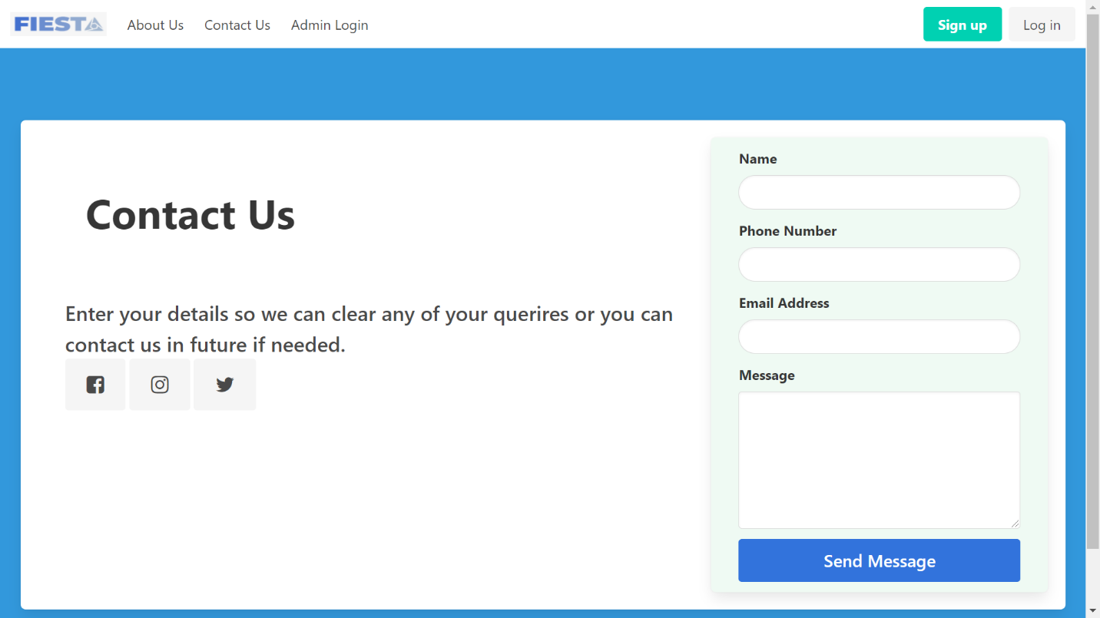
4. Admin login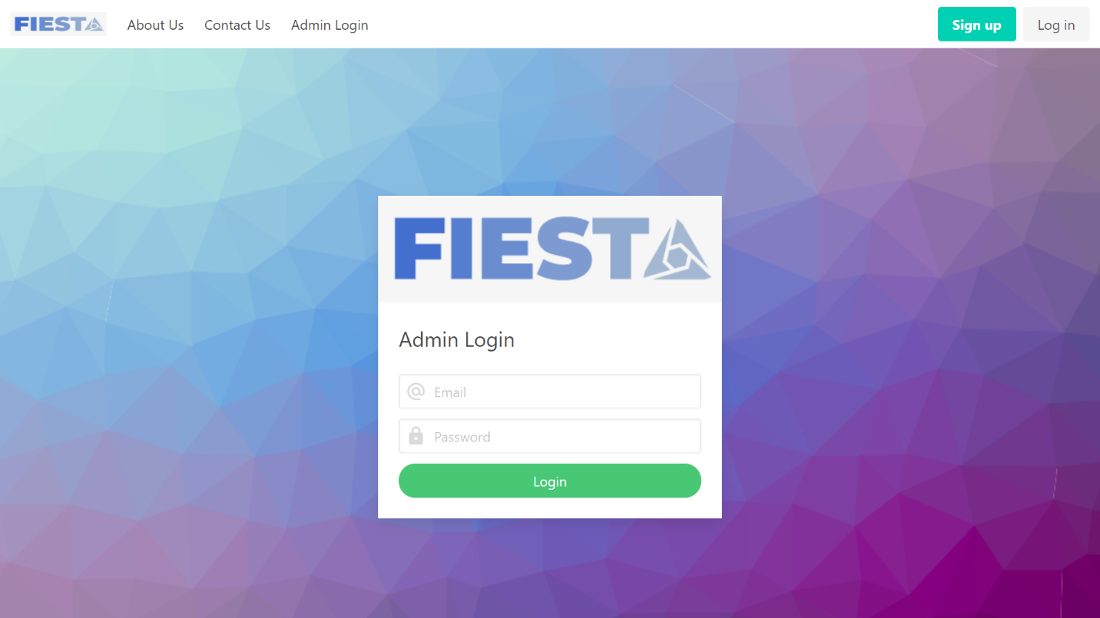
5. Student login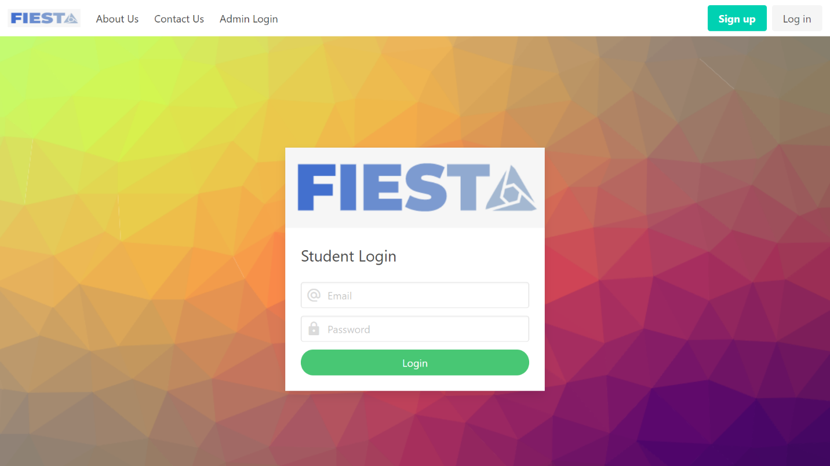
6. Student Registration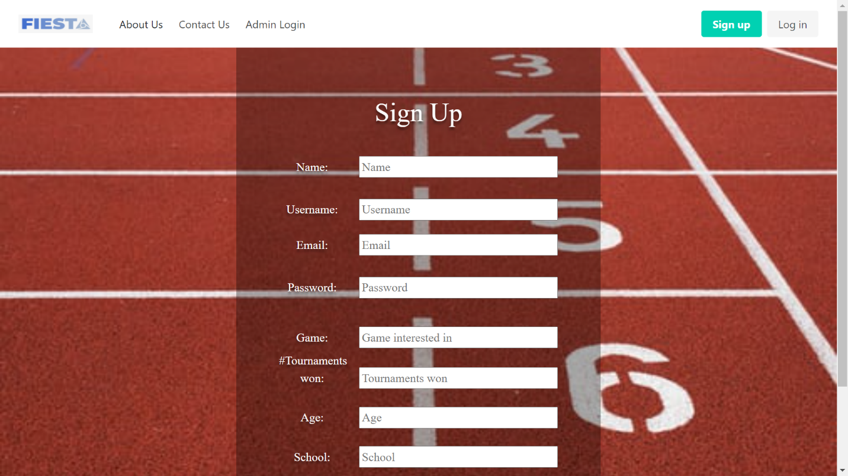
7. Admin Dashboard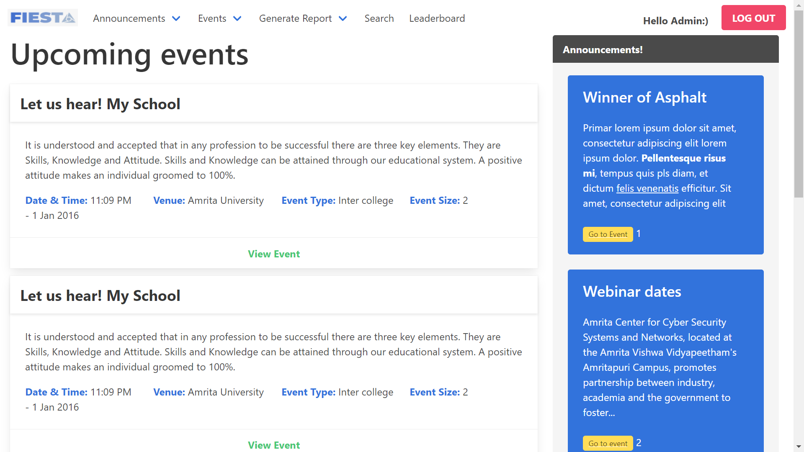
8. Dropdown menu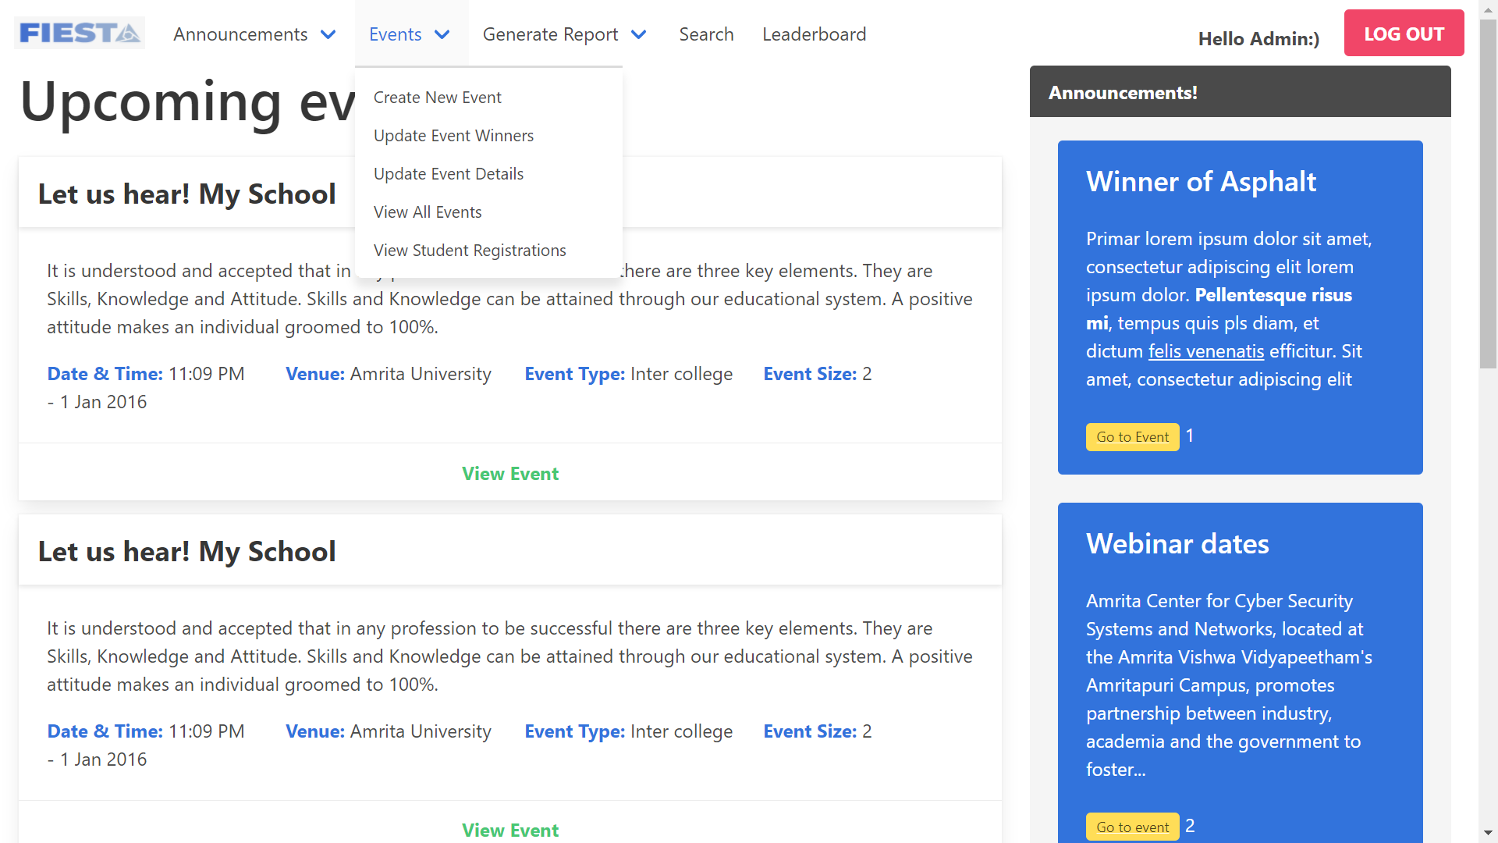
9. Add new announcement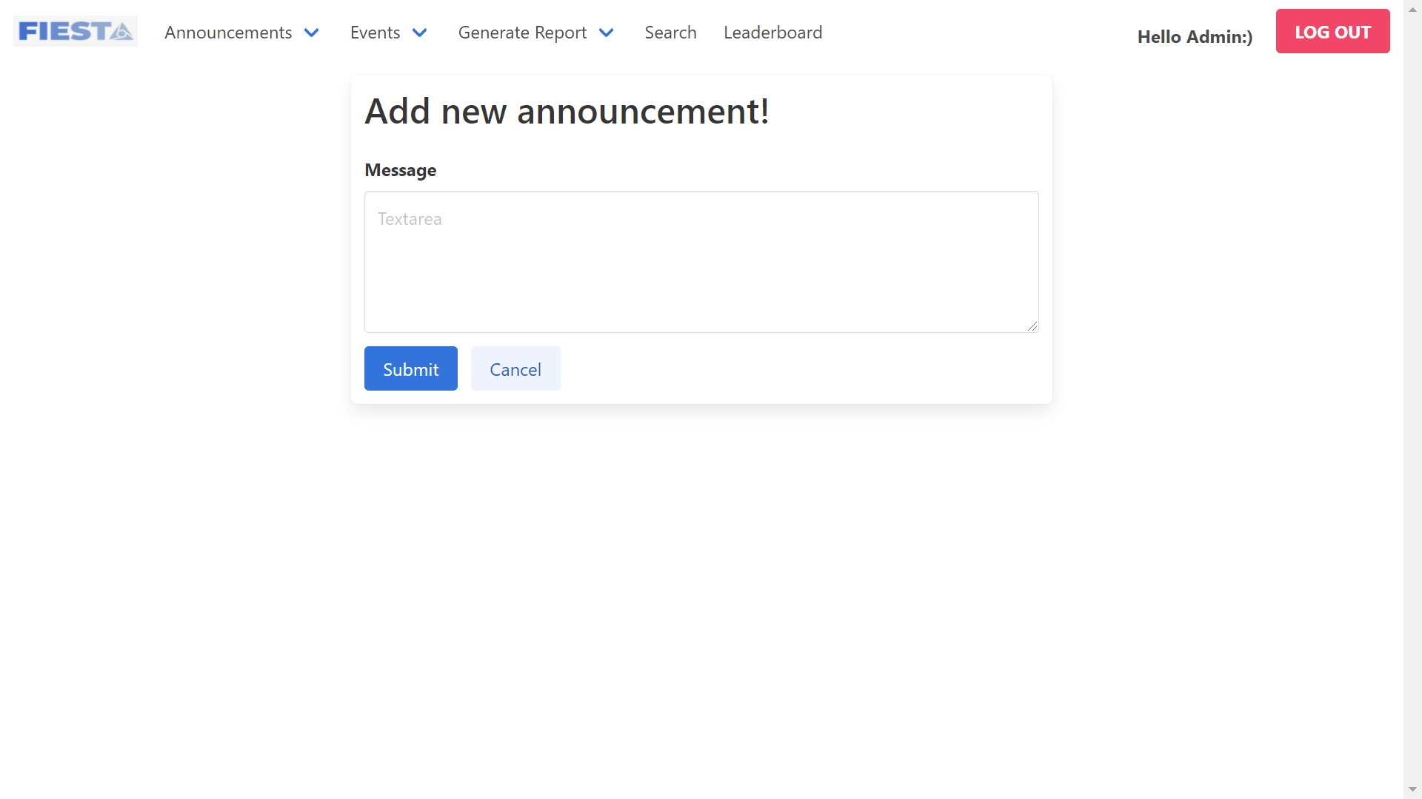
10. Modify the Announcement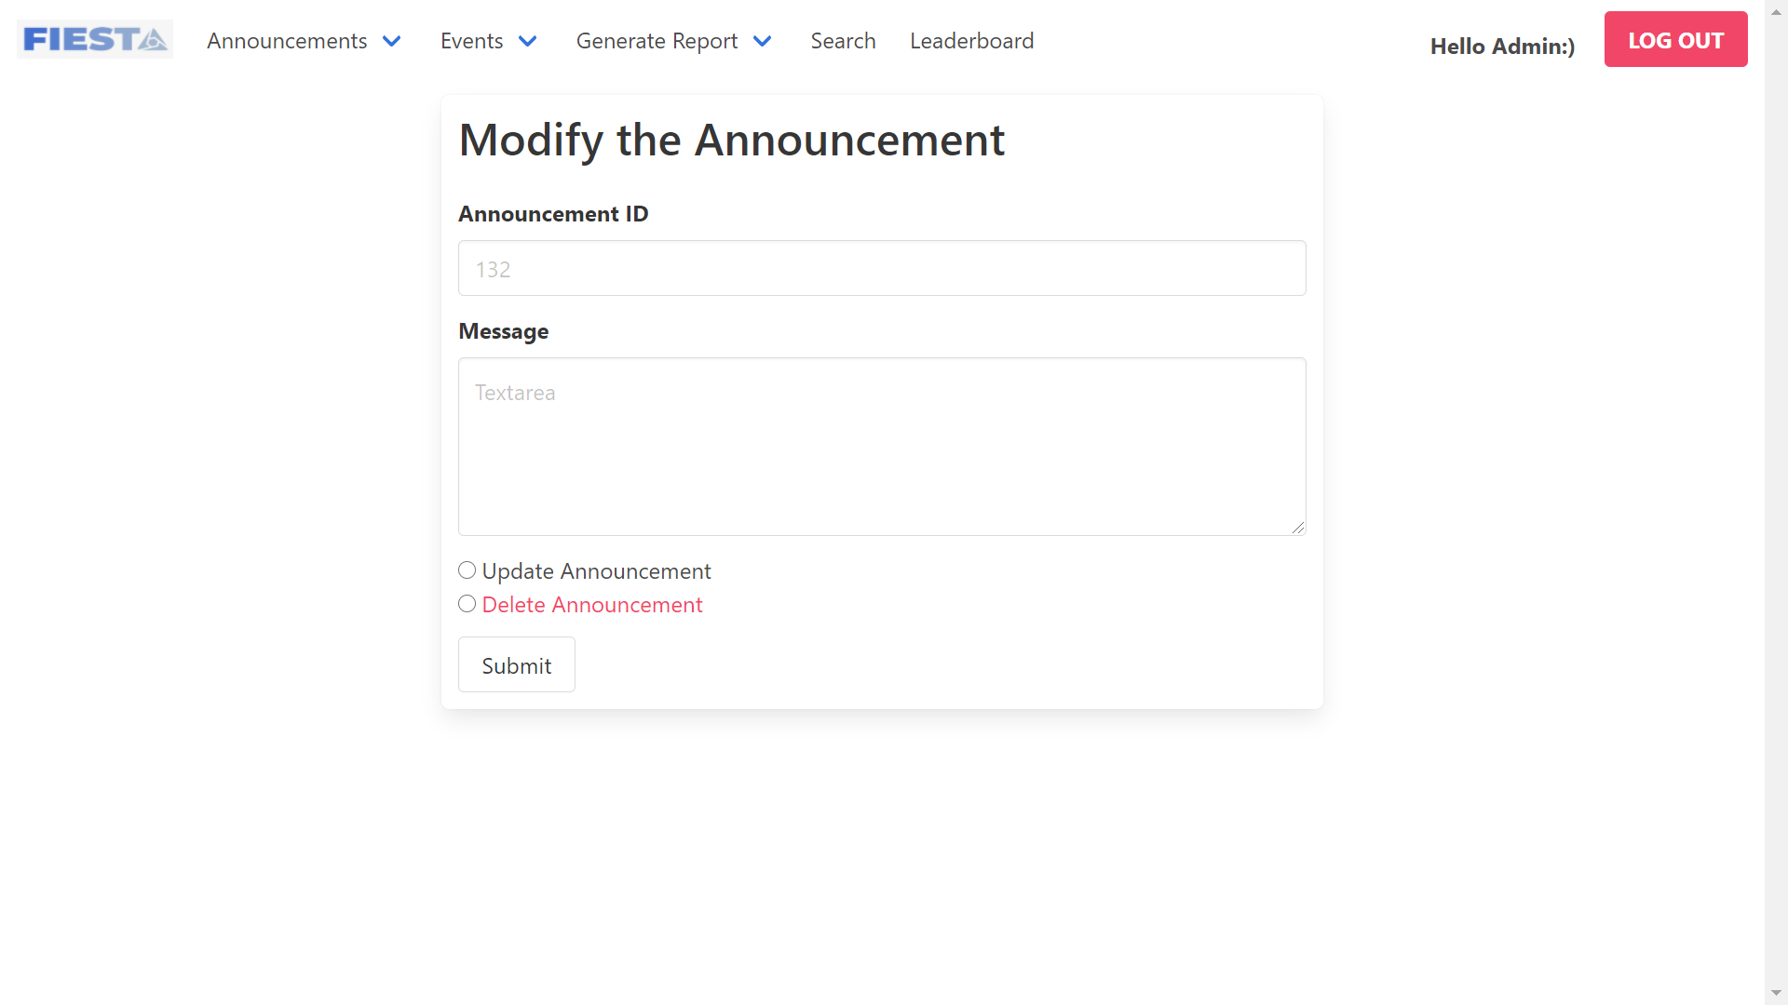
11. Portal to view latest news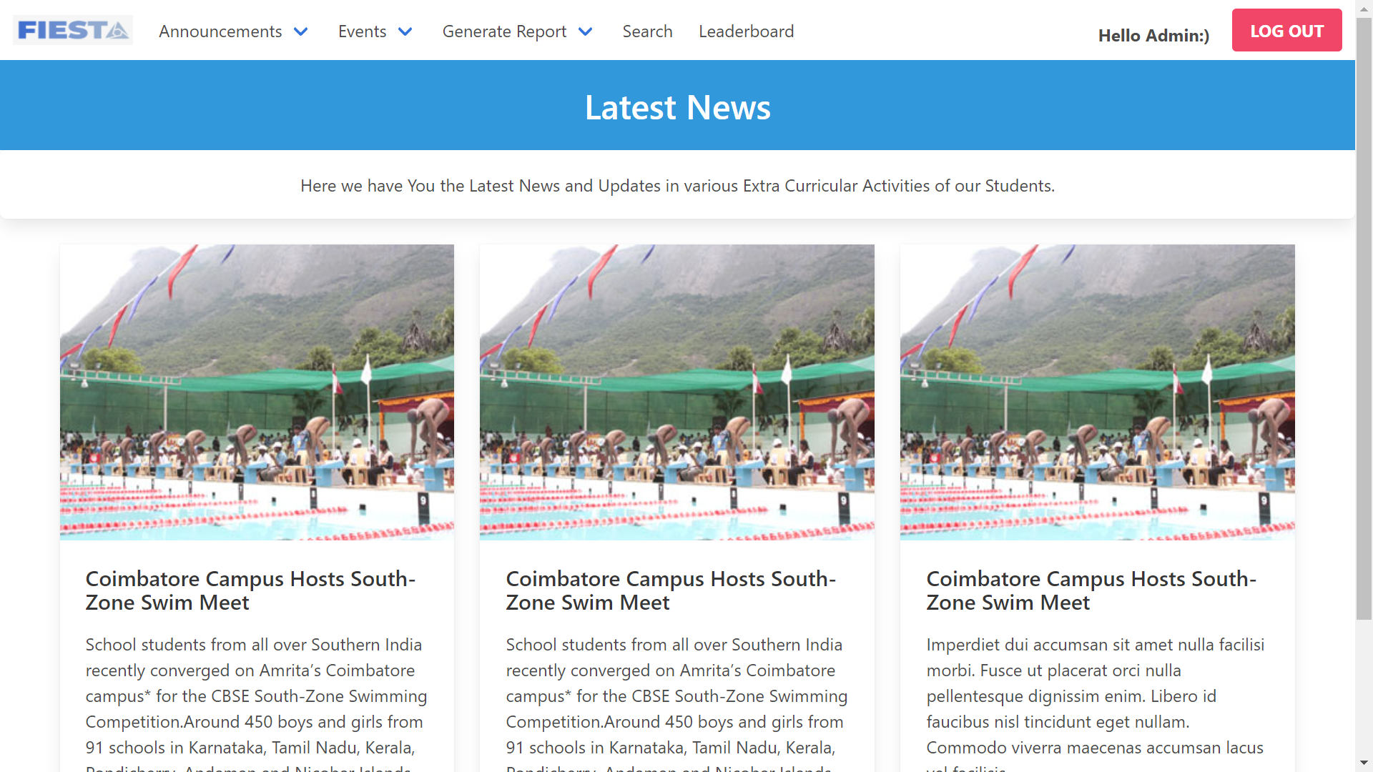
12. Form to create a new event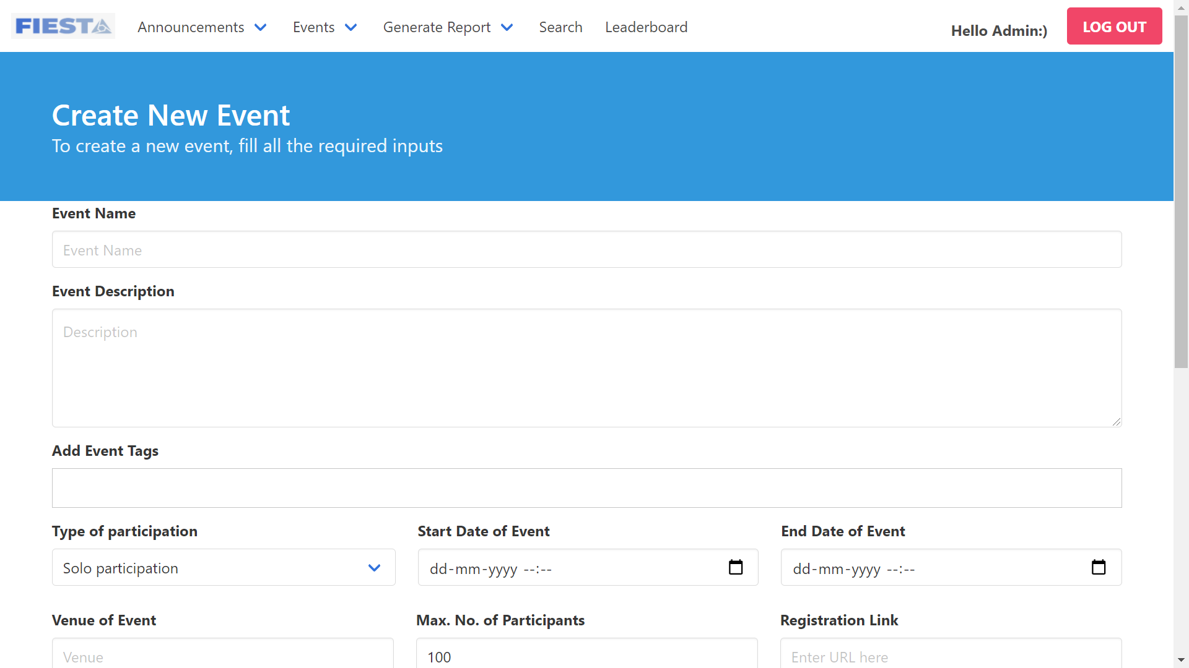
13. Form to update winners post event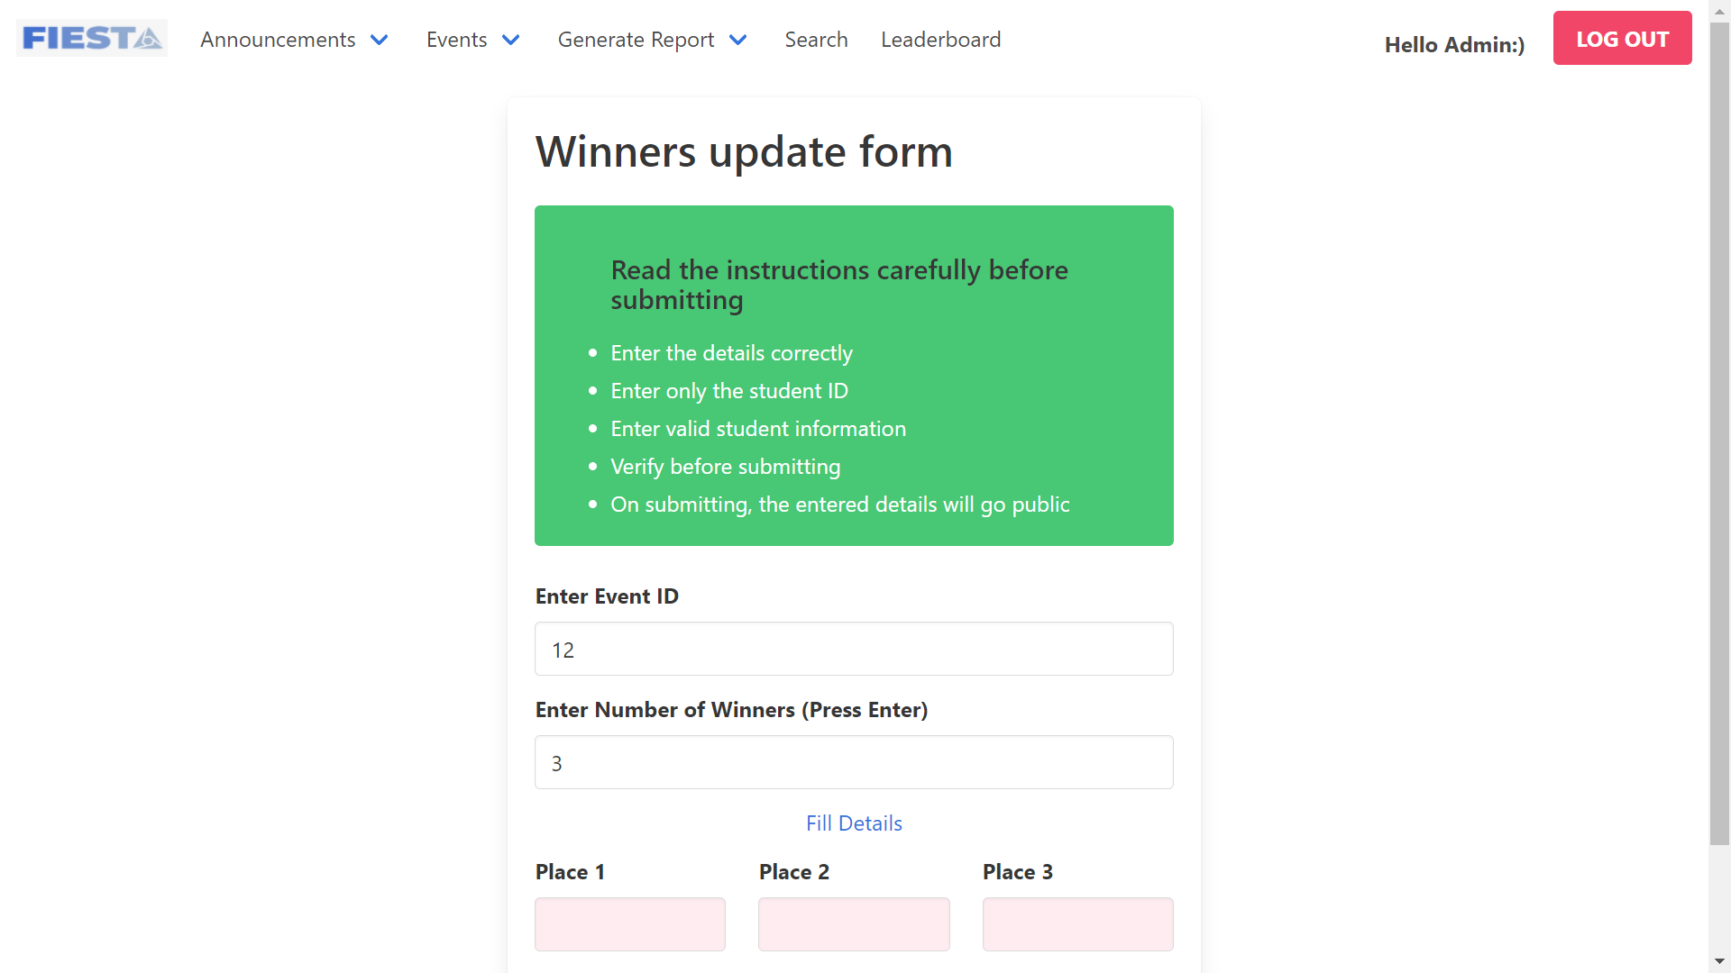
14. Form to update event details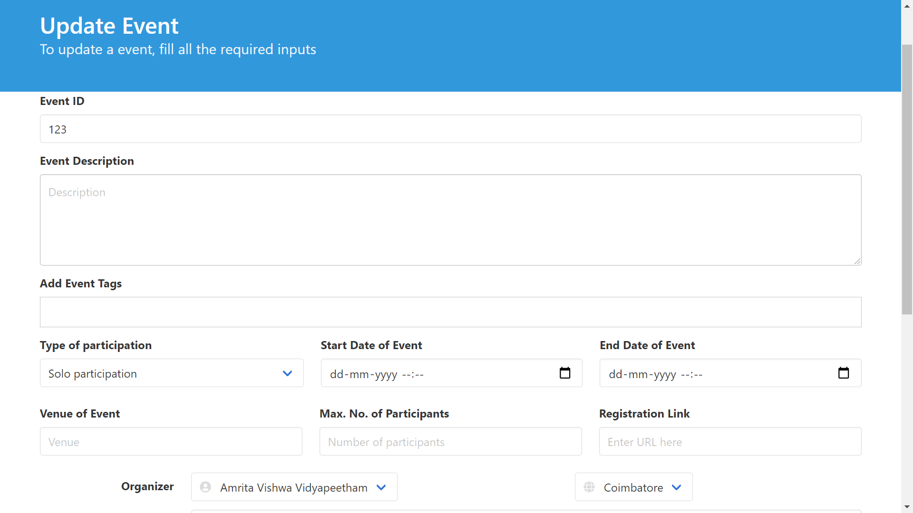
15. Event details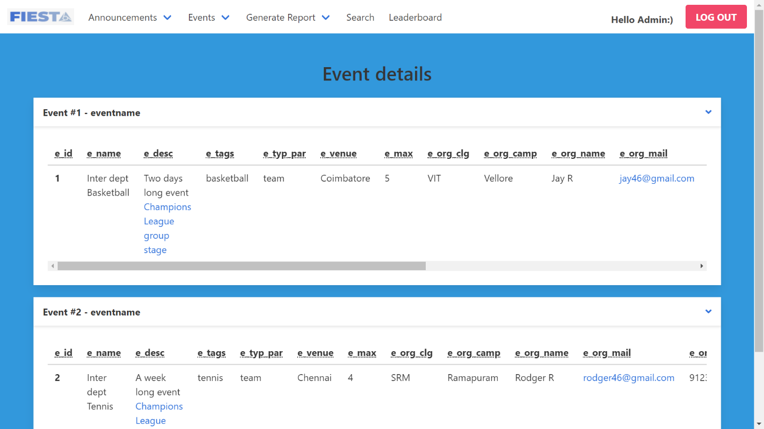
16. View student registrations event wise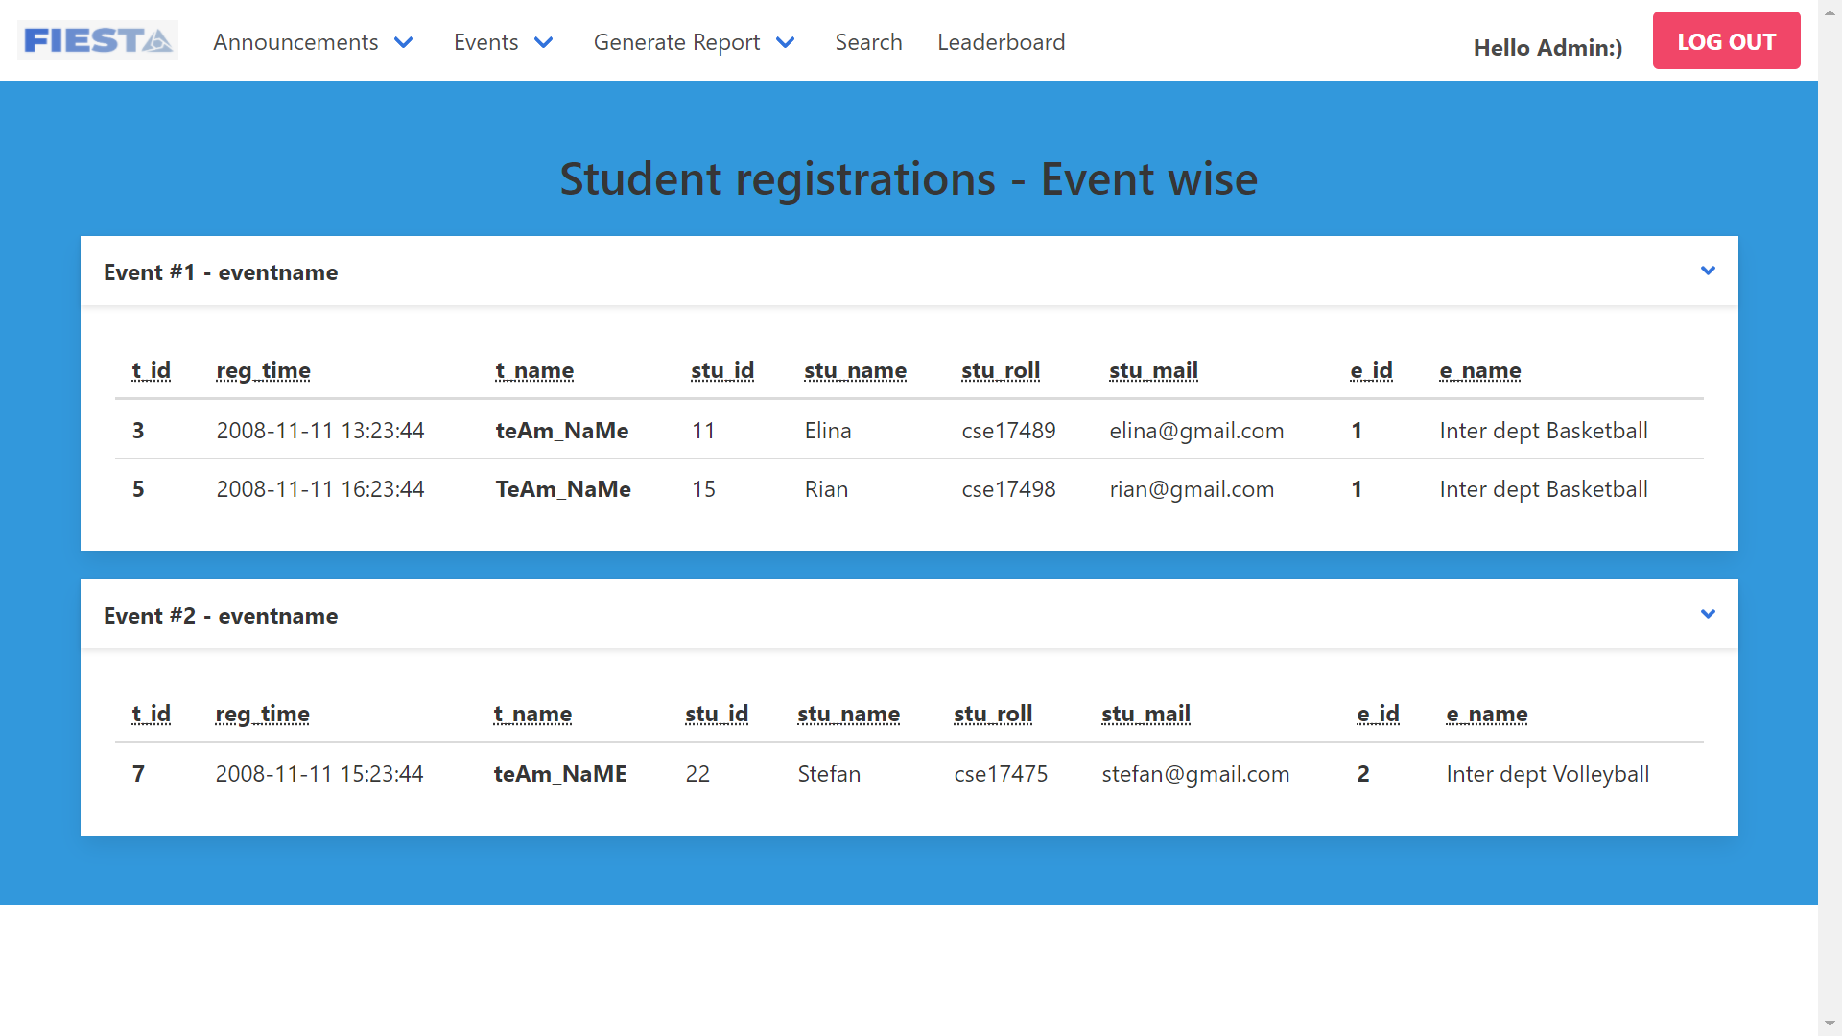
17. Generate report based on Input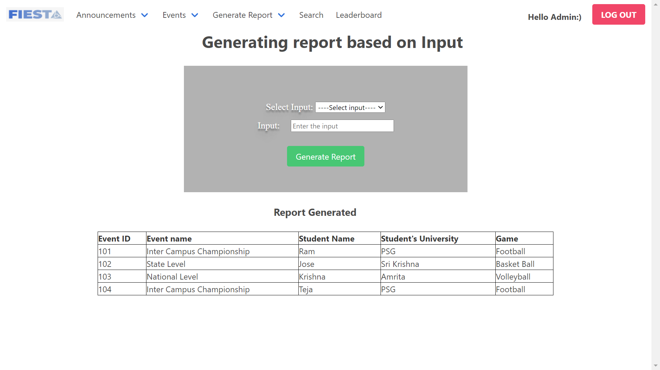
18. Generate report based on duration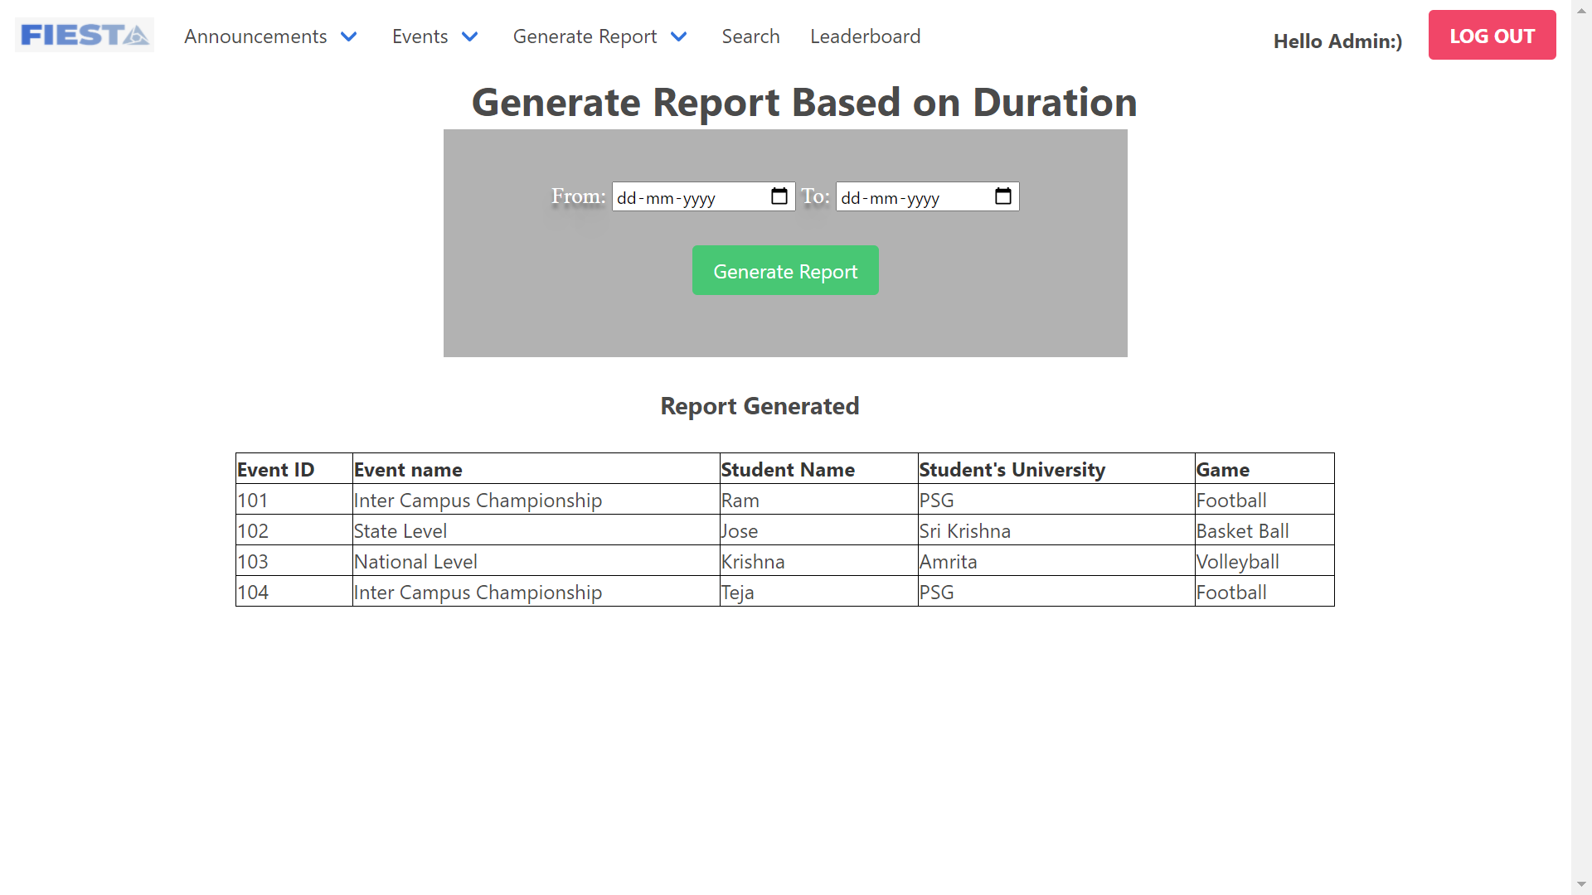
19. Search student based on student name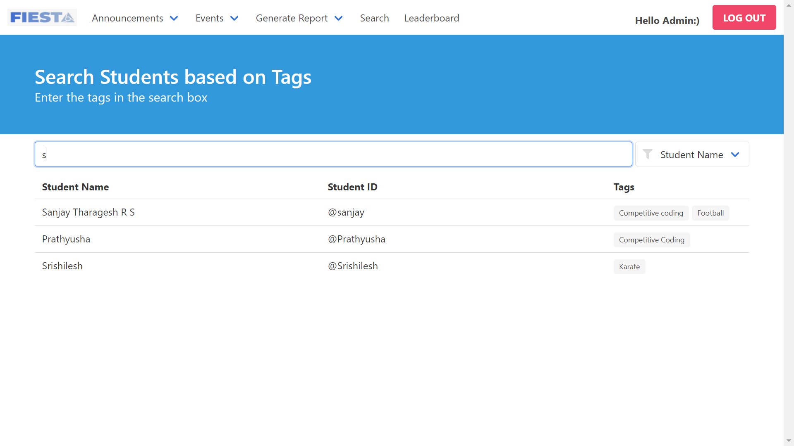
20. Search students based on tag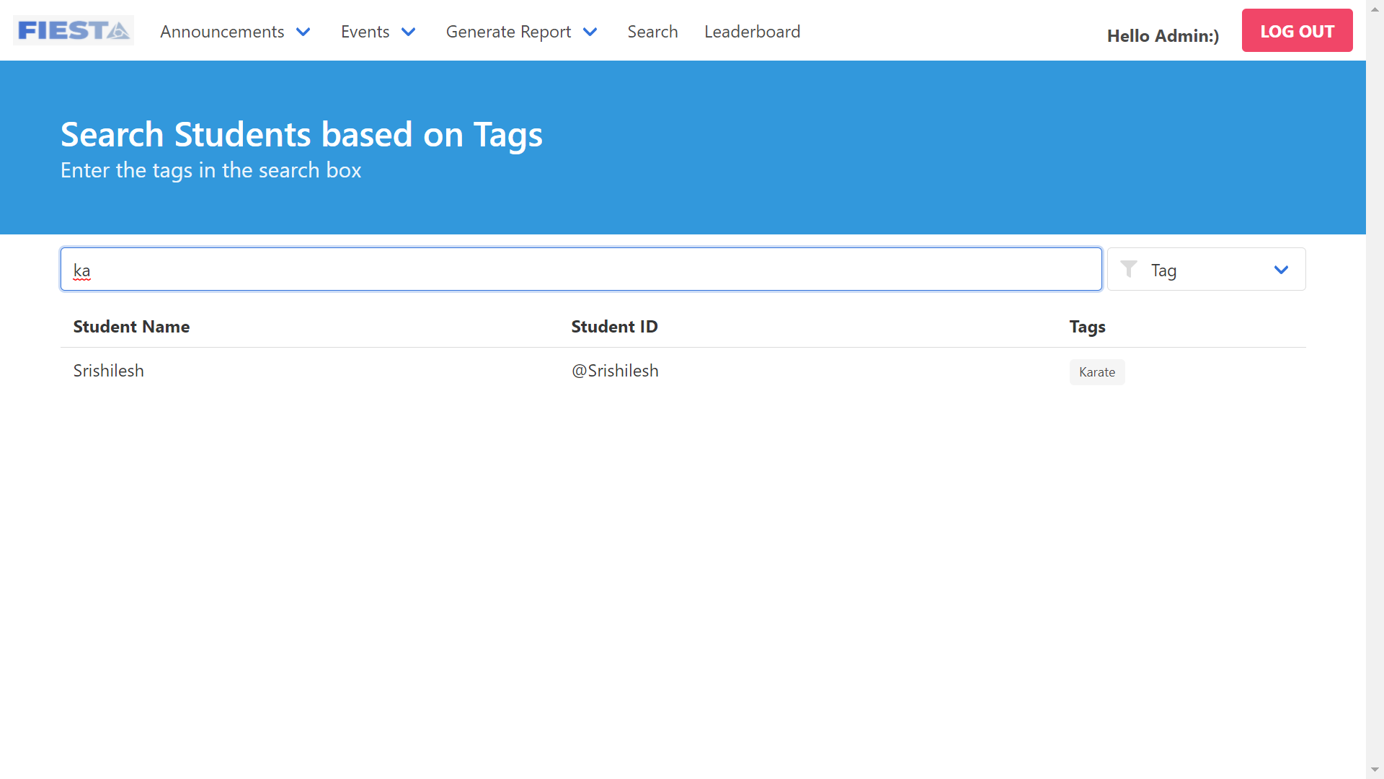
21. Leaderboard table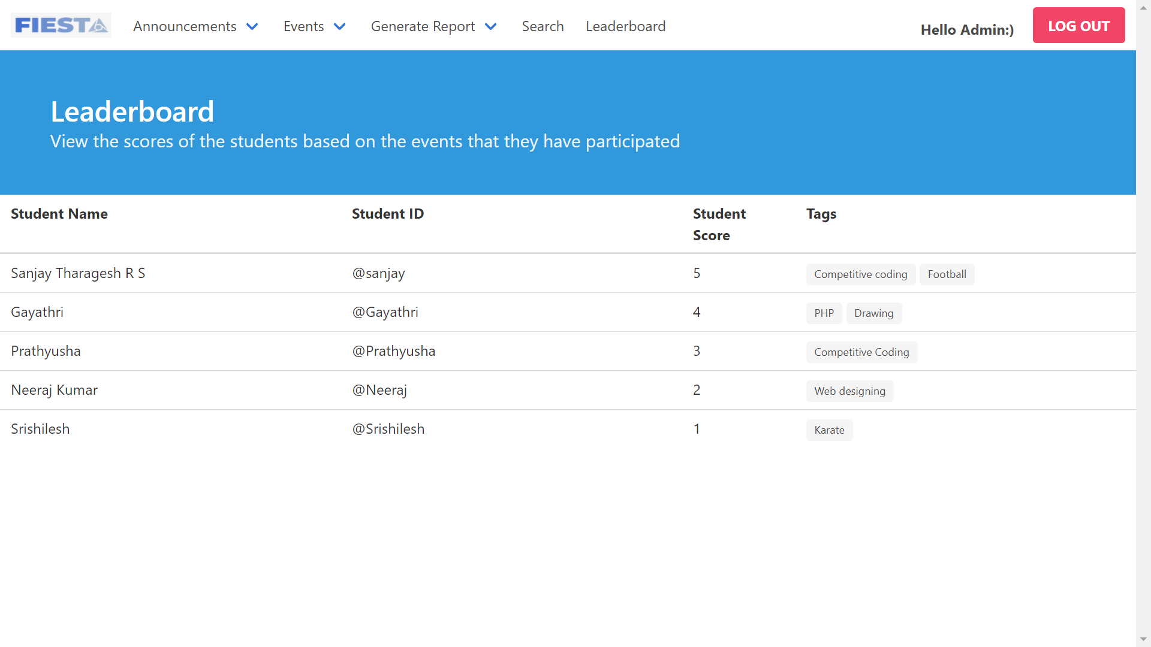
22. Event description page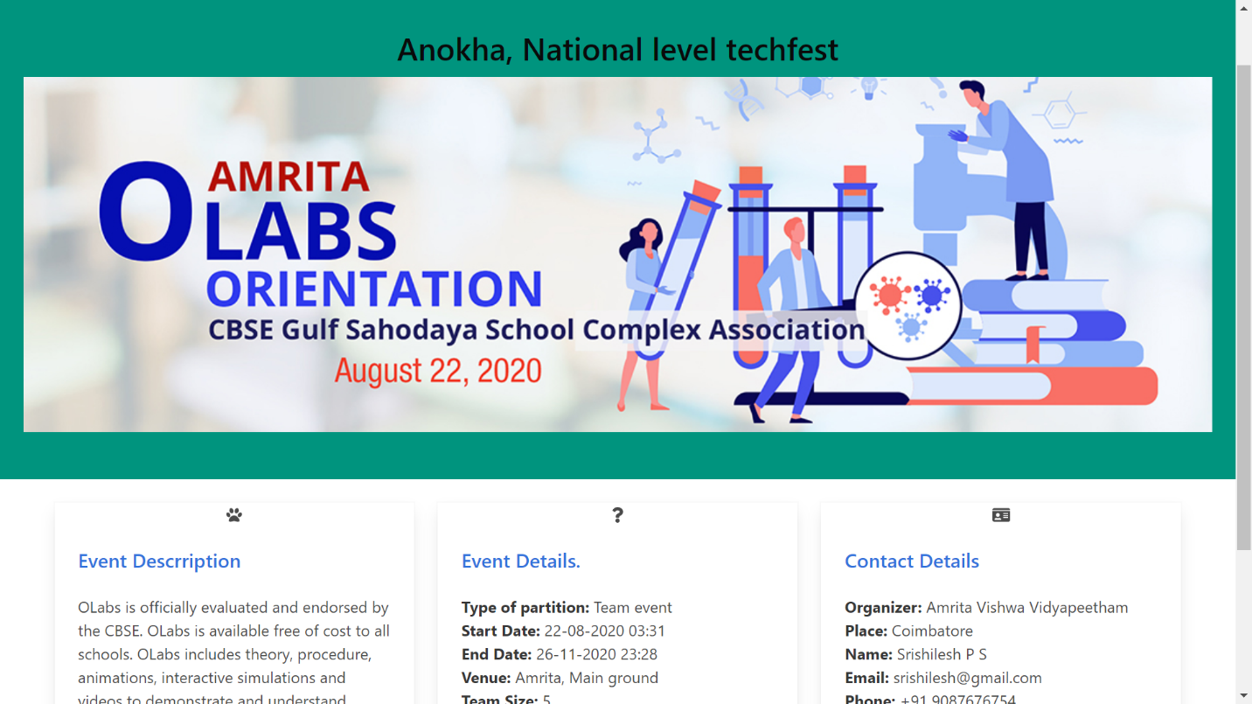
23. Student profile page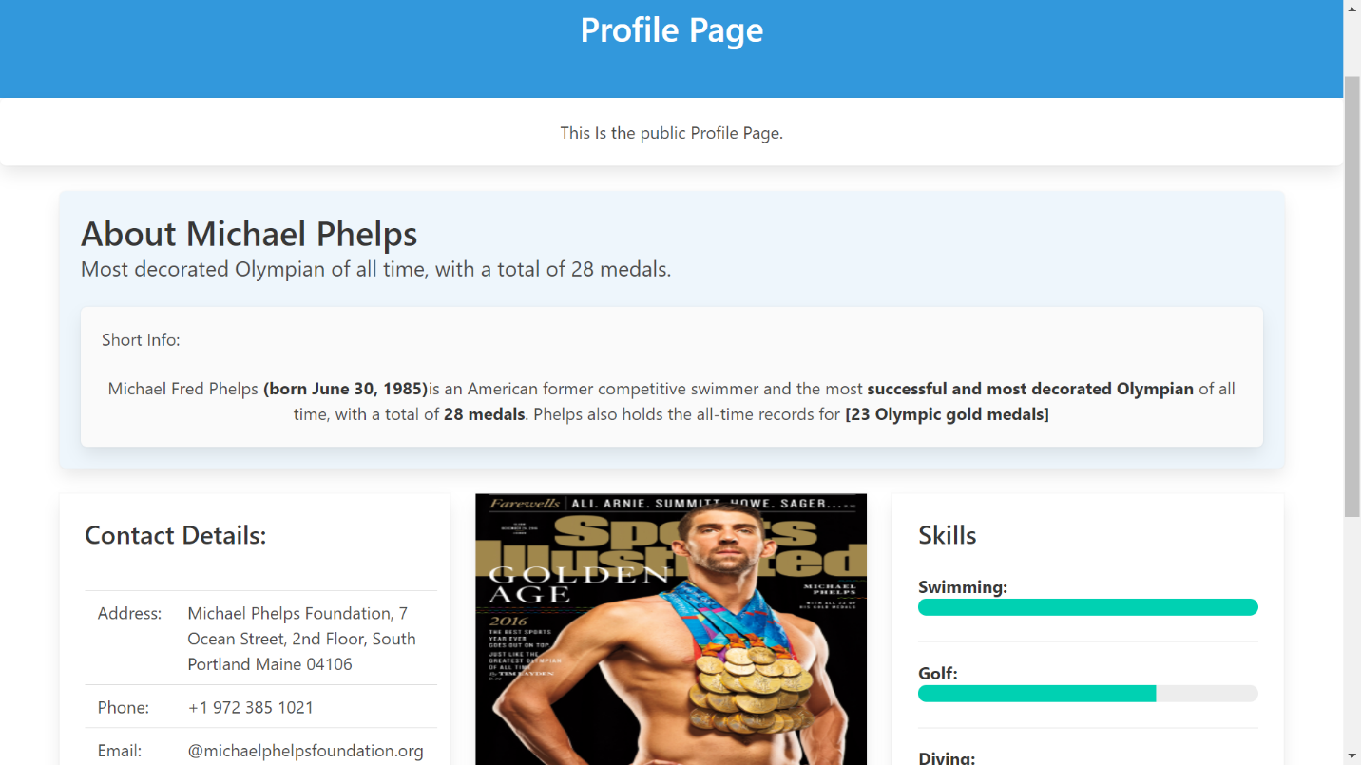
24. Update student details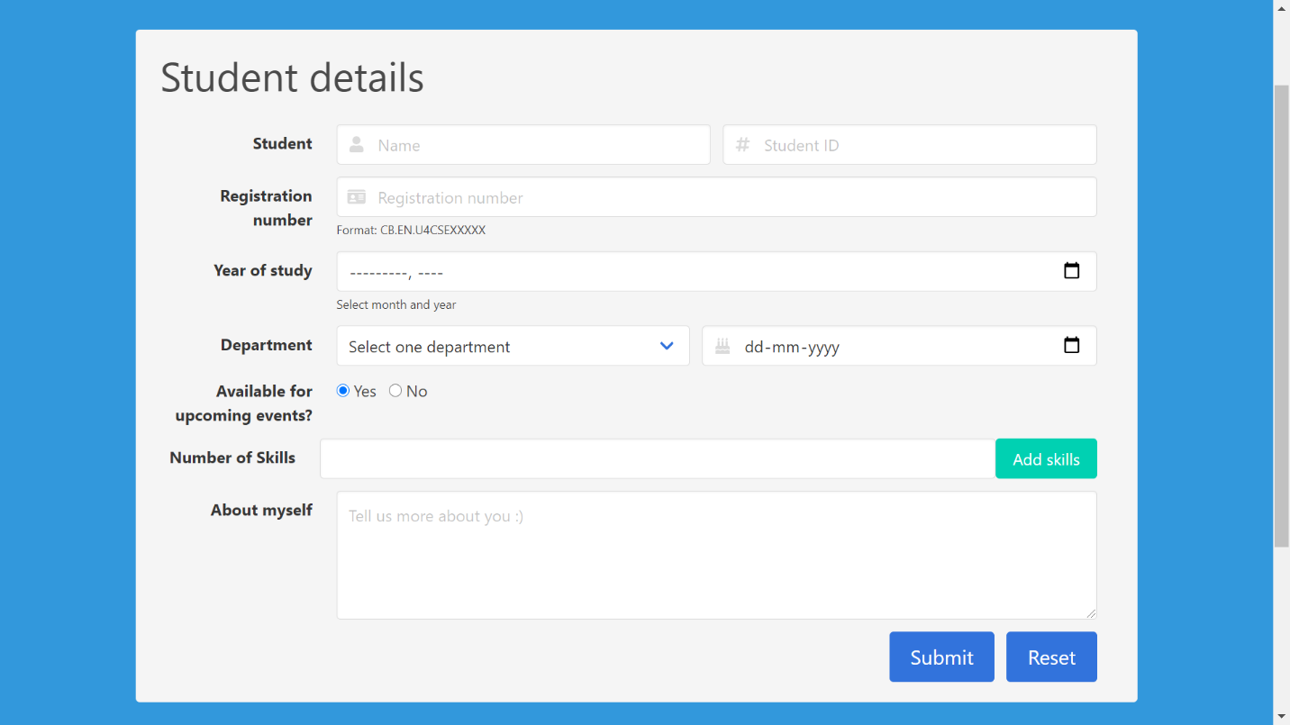
25. Update Student achievements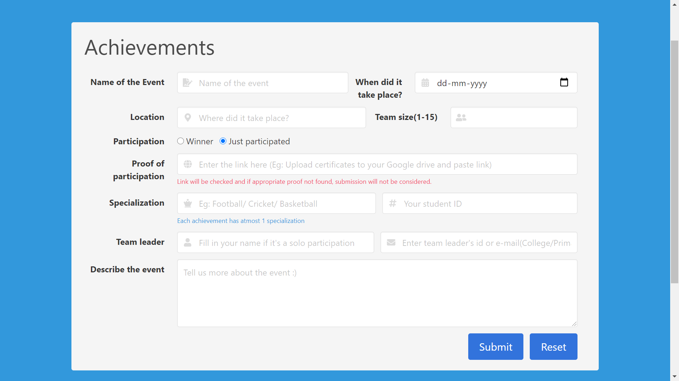
26. Update student contact details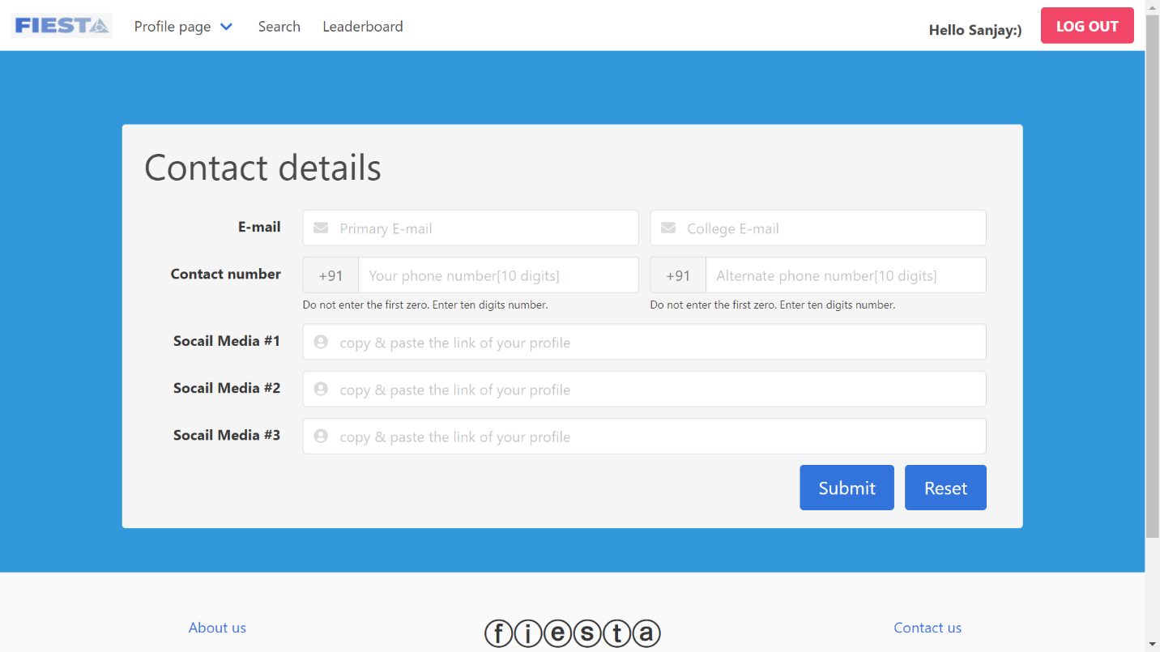

### Hardware Interfaces

*Not applicable to our project*

### Software Interfaces

* The EMS interfaces with other software components or products, including other systems, utility software, databases, and operating systems.
* EMS requires Java to be installed on the system, more specifically Java version 7 or 8 for its latest release.
* The software will be using Java servlets to communicate with MySQL hosted on AWS-RDS using JDBC.

## Functional Requirements

### LANDING PAGE

* **About Us**
* **Contact Us**
* **Admin Login**
* **Student Login**
* **Student Registration**

### STUDENT:

* **Public profile**: Profile for the World to view and admire
* **Private profile:** Student can edit his/her personal, achievements & contact details
* **View events**: View Past, present and upcoming events
* **One click registration:** Solo/Team registrations for Inter/Intra college events
* **Search for teammates**: Find your teammates based on skills
* **Student leader board**: Ranks the students based on participation and winning of events
* **View winners of the event:** Event wise winner list
* **Announcements section:** Get to know the latest updates regarding events
* **Search for teammates**: Find your teammates based on skills
* **Student leader board**: Ranks the students based on participation and winning of events
* **View winners of the event:** Event wise winner list
* **Announcements section:** Get to know the latest updates regarding events
* **Search for teammates**: Find your teammates based on skills
* **Student leader board**: Ranks the students based on participation and winning of events
* **View winners of the event:** Event wise winner list
* **Announcements section:** Get to know the latest updates regarding events

**3.3.3 ADMIN**:

* **Add/Remove/Update events**: Full access for event management
* **Generate Report**: Summarize events within a period (weekly, monthly and yearly)
* **View student registrations**: View all registrations in one portal
* **View events details:** Displays details eventwise
* **Event winner’s announcement**: Declare the winners
* **Student Leader board:** Controls how the students are ranked
* **Search students**: Pick the right students based on skills

## Use Case Model

### Use Case #1 (Landing page - U1)

**Purpose** – The main web interface for both admin and students to interact with the app.

**Requirements Traceability –** Admin and student should be from the same organization.

**Priority** - Medium

**Actors** – Student and Admin

**Use case diagram**

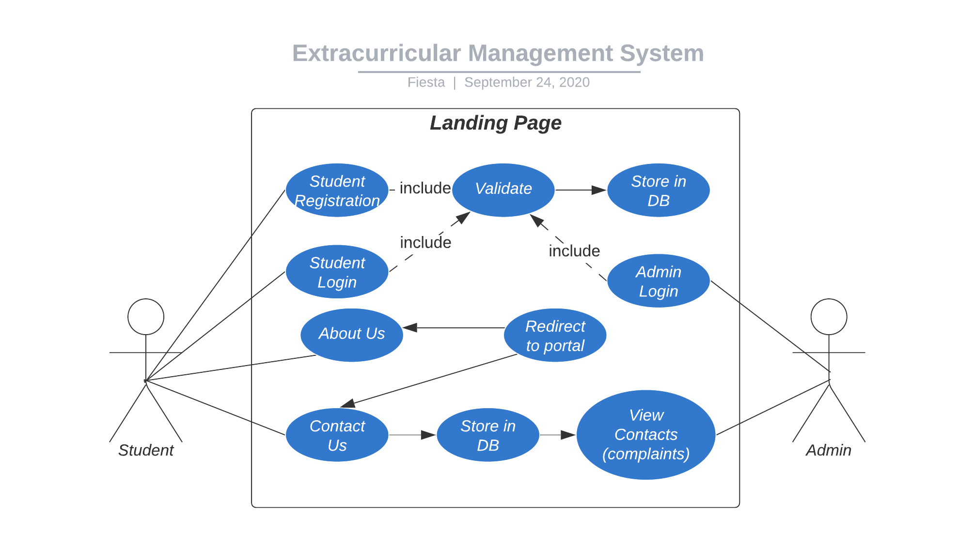

### Use Case #2 (Admin dashboard)

**Purpose** – Use cases related to admin.

**Priority** - High

**Preconditions** – Only limited number of admin access is provided for an organization.

**Actors** – Admin, Database(backend)

**Extends –** Admin login from landing page.

**Use case diagram**

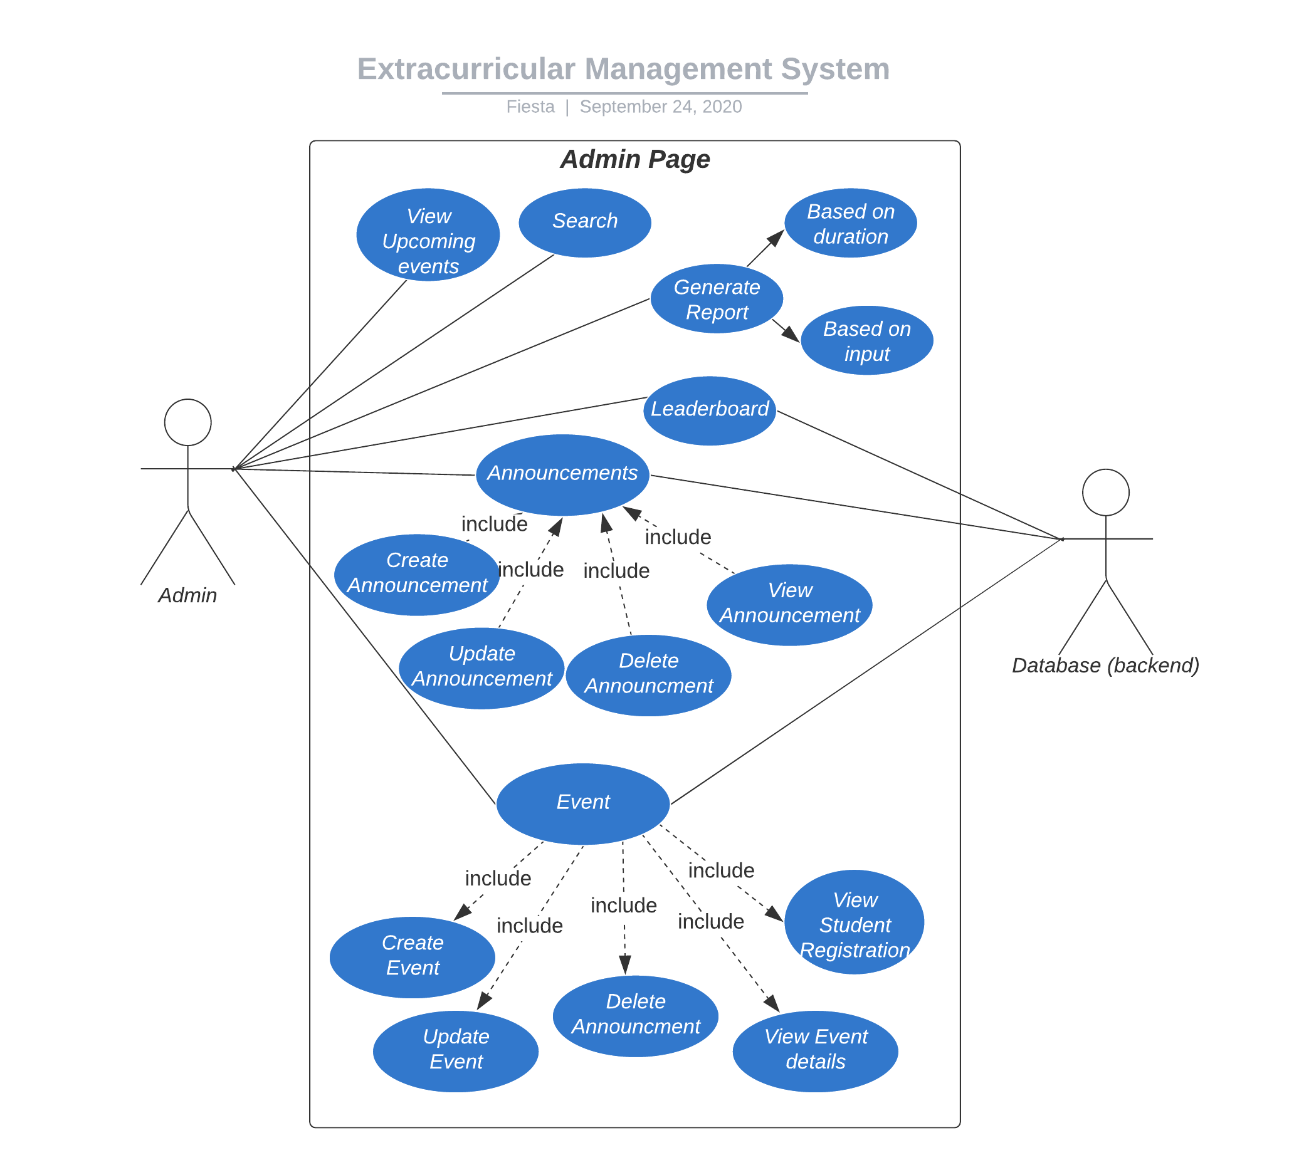

### Use Case #3 (Student dashboard)

**Purpose** – Portal for students to view, register, maintain profile for students.

**Priority** - High

**Preconditions** – Student must be member of same organization.

**Actors** – Student and Database.

**Extends –** Student login from landing page.

**Use case diagram**

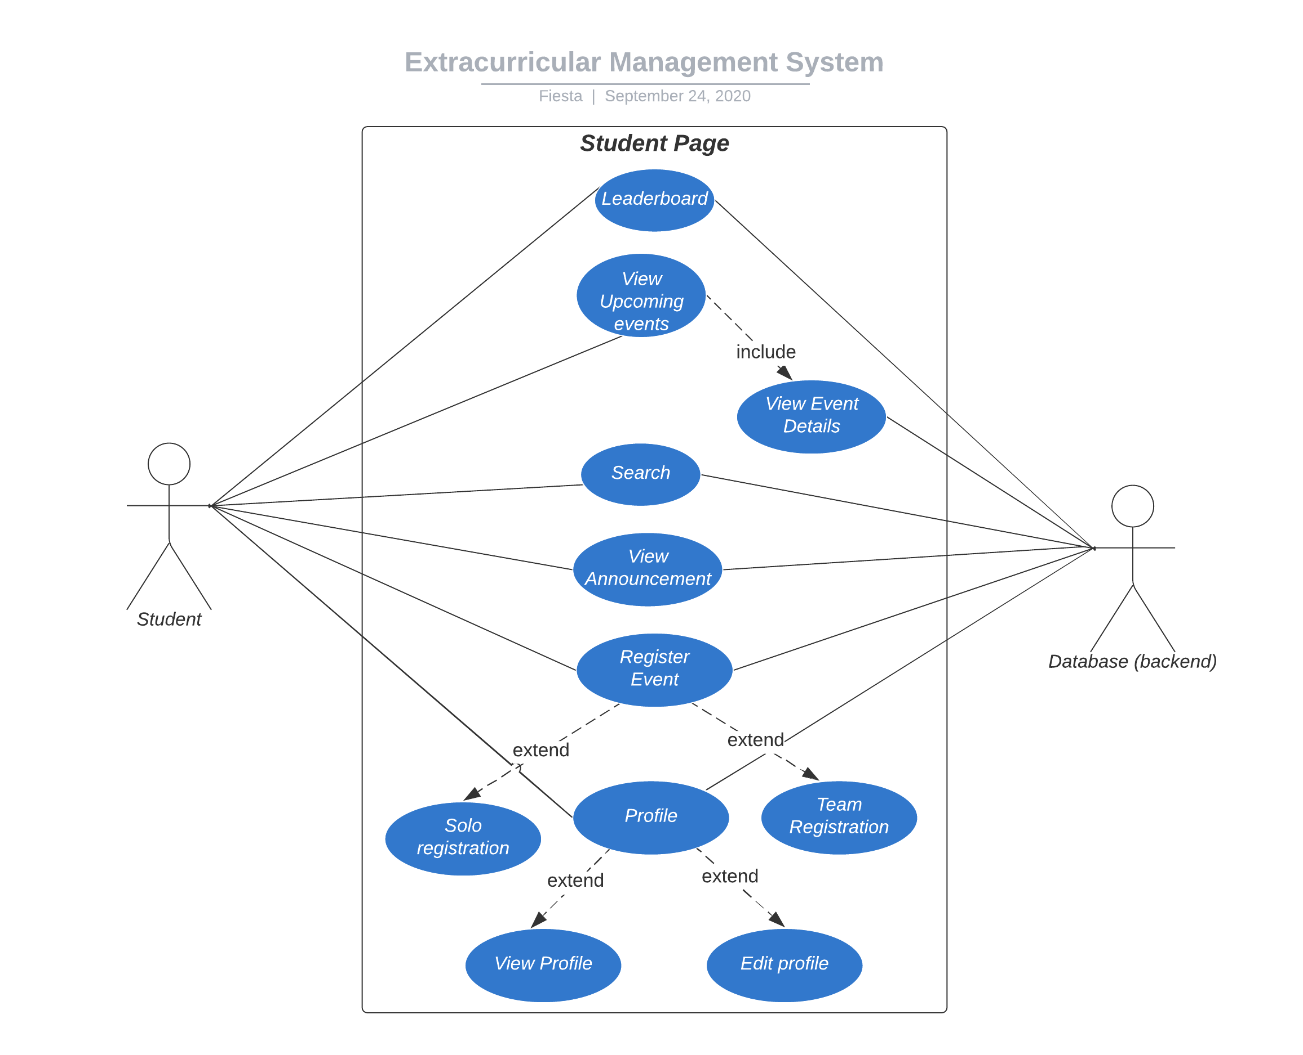

# Other Non-functional Requirements

## Performance Requirements

*<If there are performance requirements for the product under various circumstances, state them here and explain their rationale, to help the developers understand the intent and make suitable design choices. Specify the timing relationships for real time systems. Make such requirements as specific as possible. You may need to state performance requirements for individual functional requirements or features.*

*TODO: Provide performance requirements based on the information you collected from the client/professor. For example, you can say “P1. The secondary heater will be engaged if the desired temperature is not reached within 10 seconds”>*

## Safety and Security Requirements

*<Specify those requirements that are concerned with possible loss, damage, or harm that could result from the use of the product. Define any safeguards or actions that must be taken, as well as actions that must be prevented. Refer to any external policies or regulations that state safety issues that affect the product’s design or use. Define any safety certifications that must be satisfied. Specify any requirements regarding security or privacy issues surrounding use of the product or protection of the data used or created by the product. Define any user identity authentication requirements.*

*TODO:*

* *Provide safety/security requirements based on your interview with the client - again you may need to be somewhat creative here. At the least, you should have some security for the mobile connection.*

## Software Quality Attributes

*<Specify any additional quality characteristics for the product that will be important to either the customers or the developers. Some to consider are: adaptability, availability, correctness, flexibility, interoperability, maintainability, portability, reliability, reusability, robustness, testability, and usability. Write these to be specific, quantitative, and verifiable when possible. At the least, clarify the relative preferences for various attributes, such as ease of use over ease of learning.*

*TODO: Use subsections (e.g., 4.3.1 Reliability, 4.3.2 Adaptability, etc…) provide requirements related to the different software quality attributes. Base the information you include in these subsections on the material you have learned in the class. Make sure, that you do not just write “This software shall be maintainable…” Indicate how you plan to achieve it, & etc…Do not forget to include such attributes as the design for change (e.g. adapting for different sensors and heating/AC units, etc.). Please note that you need to include* ***at least*** *2 quality attributes. You can Google for examples that may pertain to your system.>*

# Other Requirements

*<This section is* ***Optional.*** *Define any other requirements not covered elsewhere in the SRS. This might include database requirements, internationalization requirements, legal requirements, reuse objectives for the project, and so on. Add any new sections that are pertinent to the project.>*

**Appendix A – Data Dictionary**

*<Data dictionary is used to track all the different variables, states and functional requirements that you described in your document. Make sure to include the complete list of all constants, state variables (and their possible states), inputs and outputs in a table. In the table, include the description of these items as well as all related operations and requirements.>*

**Appendix B - Group Log**

*<Please include here all the minutes from your group meetings, your group activities, and any other relevant information that will assist in determining the effort put forth to produce this document>*